
BMW WORLDWIDE SALES ANALYSIS

NAME :- AFTAB AHMAD H

CLASS:- B.COM BANKING AND INSURANCE

This report provides a comprehensive analysis of BMW's global sales performance over the 15-year period from 2010 to 2024. The analysis reveals significant insights into revenue trends, regional distribution, and vehicle model performance across the company's international markets.

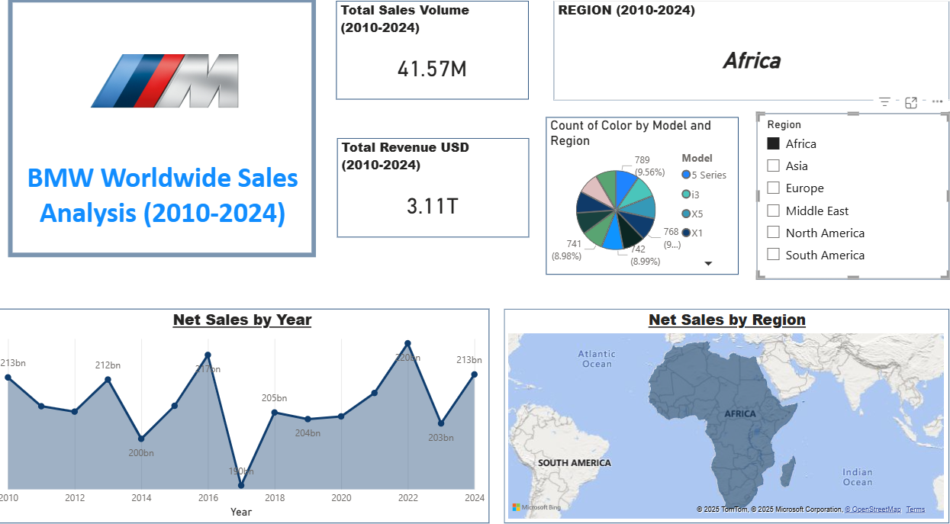

SALES PERFORMANCE OVERVIEW
Total Sales and Revenue BMW achieved remarkable sales figures during the 2010-2024 period:

